**INVESTIGATION 2**

**MATHEMATICAL MODELING: HARDY WEINBERG (by Cherylann Hollinger)**

How can mathematical models be used to investigate the relationship between the allele frequencies in populations of organisms and evolutionary change?

**Using Excel to Model H-W**

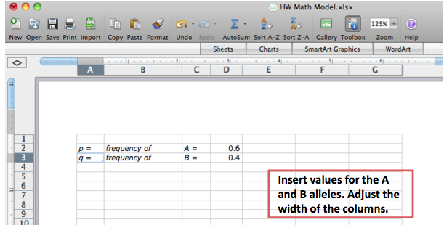

**Next step is to highlight the area you wish to format with color.**

**Note: This is an optional step.**

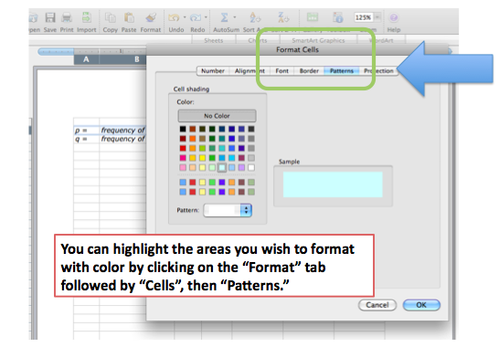

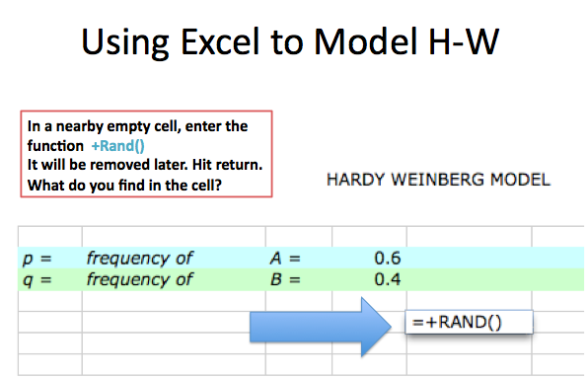

**Notice what happens. If you are using a PC, try hitting the F9 key several times to force recalculation. On a Mac, enter *cmd* + or *cmd* =. What happens to the value in the cell?**

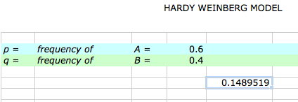

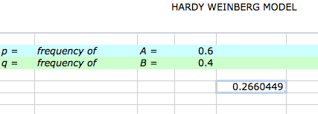

**The RAND function returns random numbers between 0 and 1 in decimal format. By using this function, this model is simulates the “random” choosing of gametes from a gene pool.**

**Go ahead and delete the RAND function in the cell. Select two gametes from the gene pool. In cell E5, generate a random number, compare it to the value of *p*, and then place either an *A* gamete or a *B* gamete in the cell. You will need two functions – the RAND function and the IF function.**

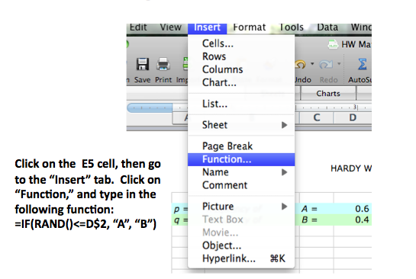

**The formula basicallay says that if a random number between 0 and 1 is less than or equal the value of *p*, then put an *A* gamete in this cell, or if it is NOT less than or equal to the value of *p*, then put a *B* gamete in this cell.**

**Your spreadsheet should look like this.**

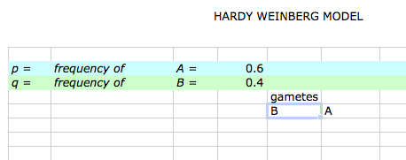

**Try recalculating 10-20 times. This is what will happen.**

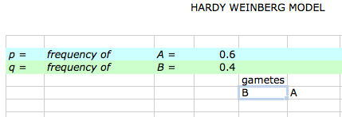

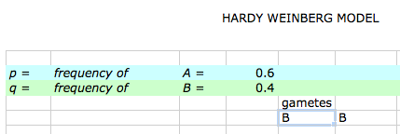

**Try changing your *p*  value to 0.8 or 0.9. Does the spreadsheet still work as expected? Try some lower *p* values.**

**Copy these 2 formulas in E5 and F5 down for about 16 rows to represent gametes that will form 16 offspring for the next generation. To copy the formulas, click on the bottom right-hand corner of the cell and, with your finger pressed down on the mouse, drag the cell downward.**

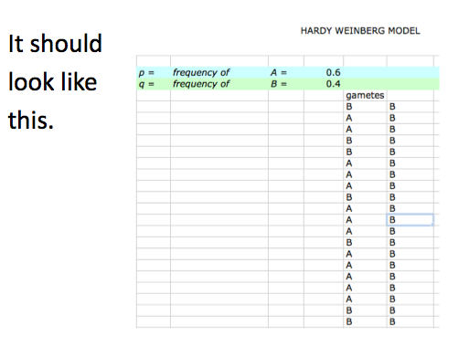

**You will put the zygotes in cell G5. In cell G5 enter the function =CONCATENATE(E5,F5) and then copy this formula down as far as you have gametes.**

**It should look like this.**

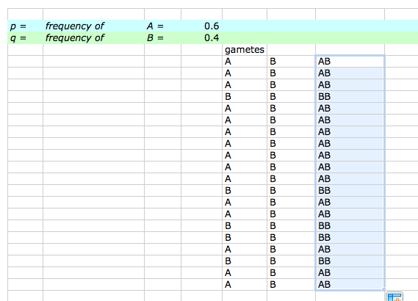

**The next columns on the spreadsheet are H, I, and J. These are “housekeeping” columns. They keep track of the numbers of each zygote’s genotype. You will enter the following functions for each column.**

**The function in cell H is =IF(G5=”AA”,1.0).**

**The function in cell J is =IF(G5=”BB”,1.0)**

**In cell I5, enter this function: =IF(G5=”AB”,1,(IF(G5=”BA”,1.0))).**

**Enter the labels for the columns you have been working on. Cell E4 *gametes*, Cell G5 *AA* in cell H4, and *BB* in Cell J4.**

**It should look like this.**

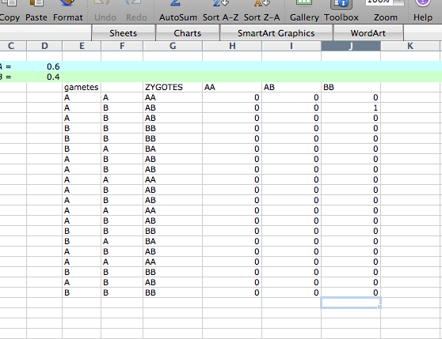

**Try recalculating a number of times to make sure everything is working as expected.**

**Don’t go on until you are sure the spreadsheet is making correct calculations. Try different values for *p*. Make sure the number of zygotes adds up.**

**Copy the cells E5 through J5 down as many zygotes as you would like in the first generation. It should look like this.**

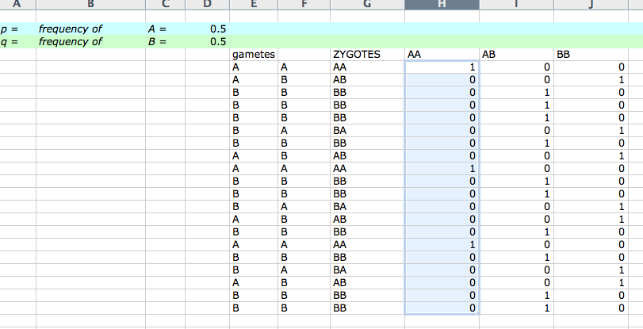

**Use the SUM function to calculate the numbers of each genotype in the H, I, and J columns. It should look like this.**

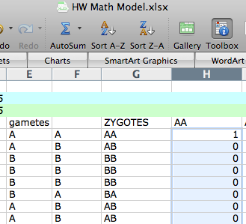

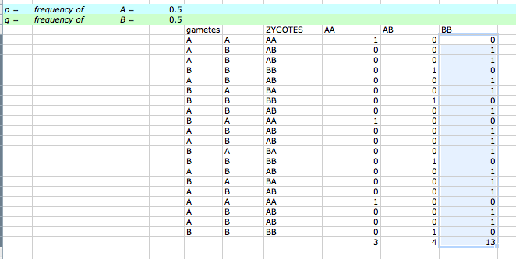

**Make a bar graph of the genotypes using the chart tool. Your graph should resemble this. All you need to do is add the title and label the X and Y axes.**

